IOT Syringe Infusion Pump

A syringe pump is a precision based pumping device that can be mounted with one or more syringes for high precision delivery of fluids. Syringe pumps are widely used in medical sector to provide a small but accurate amounts of medications. This is done using precision motorized systems to drive syringe pistons and achieve desired dosages.
Syringe pump settings are used to set the dosage in ml for the required fluids to be delivered to patient as per doctor instructions. Syringe pumps are usually mounted on side tables or IV poles for usage. The settings on a syringe pumps may include direction of flow, flow rate of fluid, time period for which the delivery is to be done. This ensures delivery of the fluid in desired amounts so as to achieve desired dosages.
Well we here propose to build an IOT based syringe infusion pump that can be monitored as well as controlled via doctors remotely over the internet. This syringe pump allows the doctor to set, modify the flow, stop the infusion of pump over the internet as per patient response. Also the system sets record of all the commands provided by doctor in a safety log for data inspection if needed.
This IOT syringe pump provides the following advantages:
- Precision delivery of medication
- Ability to remotely start stop infusion
- Ability to remotely modify parameters as per patient response
- Doctors can remotely handle patient infusions at multiple hospitals
- Automatic record keeping of all logs
- Easy to Use Device

The system makes use of a microcontroller system to handle the entire processing system. We here use an LCD display to display settings and other parameters. The machine consists of a syringe mounting to hold the syringe in place as well as press the plunder gradually as per set requirements.

The device uses a motorized ball screw based arrangement to drive the plunger pusher. The device allows for setting device parameters through device keypad as well as through the internet. When the device internet control option is active the respective doctors can see the device activated on their online portal.
The device settings include adjustment the direction flow, the flow rate, the syringe brand and size, total dosage to be delivered and so on. Once settings are fed by user offline or over IOT the machine calculates the push rate of plunger. Based on this the motor operates with accuracy to ensure the delivery of fluid gradually at set flow rate till it delivers the desired amount of fluid and stops automatically with led alert and online alert to signal the successful delivery of set dosage.
Components:
- Arduino
- DC Motor
- LCD Display
- Keypad
- Wifi Module
- Pusher Rod
- Ball Screw
- Buttons & Switches
- Electrical & Wirings
- Mounts and Joints
- Supporting Frame
- Resistors Capacitors
- Diodes Transistors
- Connectors
- Screws and Fittings

Applications:
- Infusion Pumping in Hospitals and Medical Centers

Advantages:
- Precision delivery of medication
- Ability to remotely start stop infusion
- Ability to remotely modify parameters as per patient response
- Doctors can remotely handle patient infusions at multiple hospitals
- Automatic record keeping of all logs
- Easy to Use Device

Disadvantages:
- Cannot deliver more than syringe capacity without manual refilling
- Can hold only one syringe at a time

Block Diagrams:

Front View
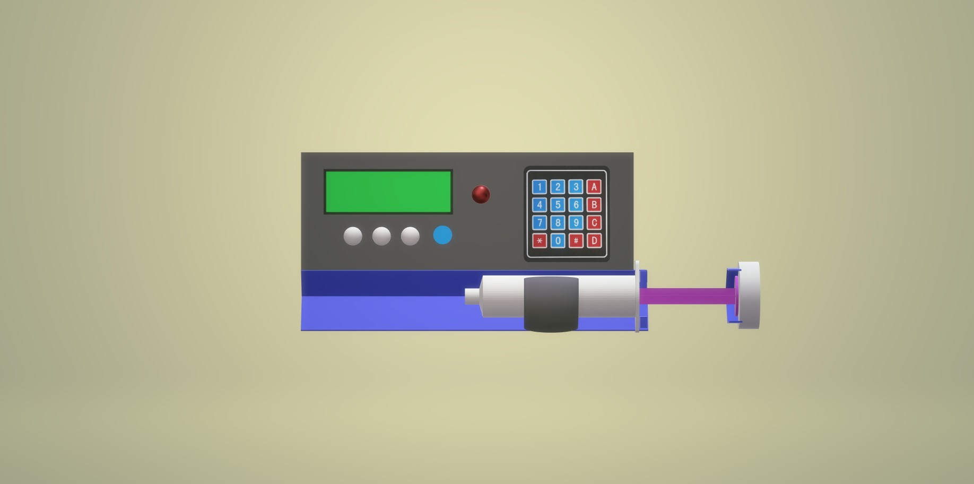

Side View



3D View



